BR STOPS - UrbanSim SE Data Update Guide

Step 1: Receive Block-Level SE Data

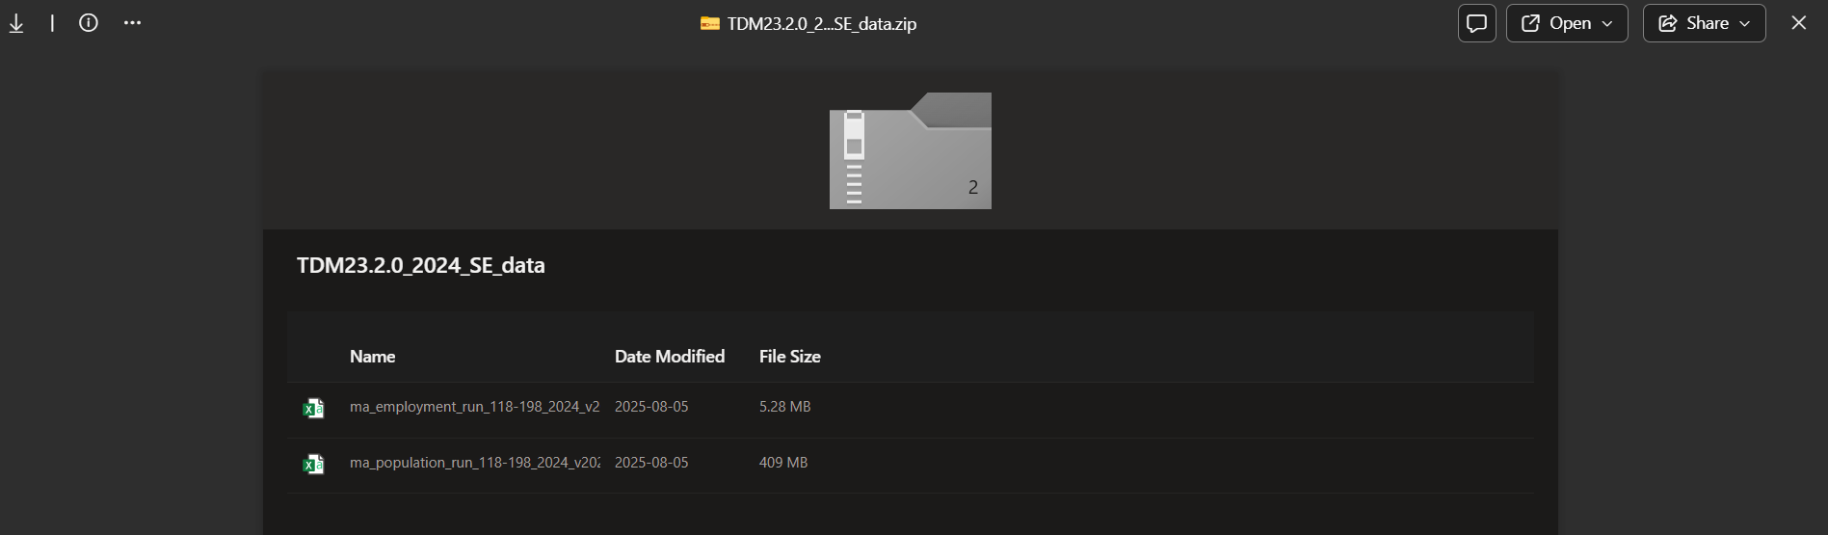

Step 2: Rebase the data with the block-to-taz conversion

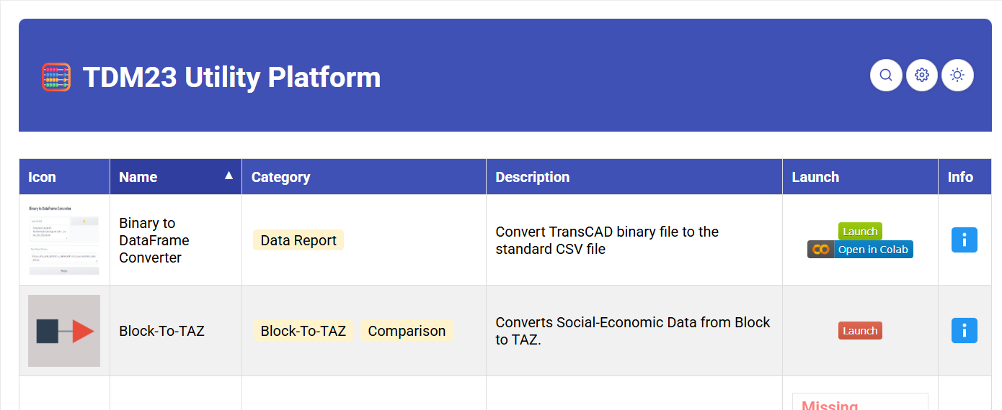

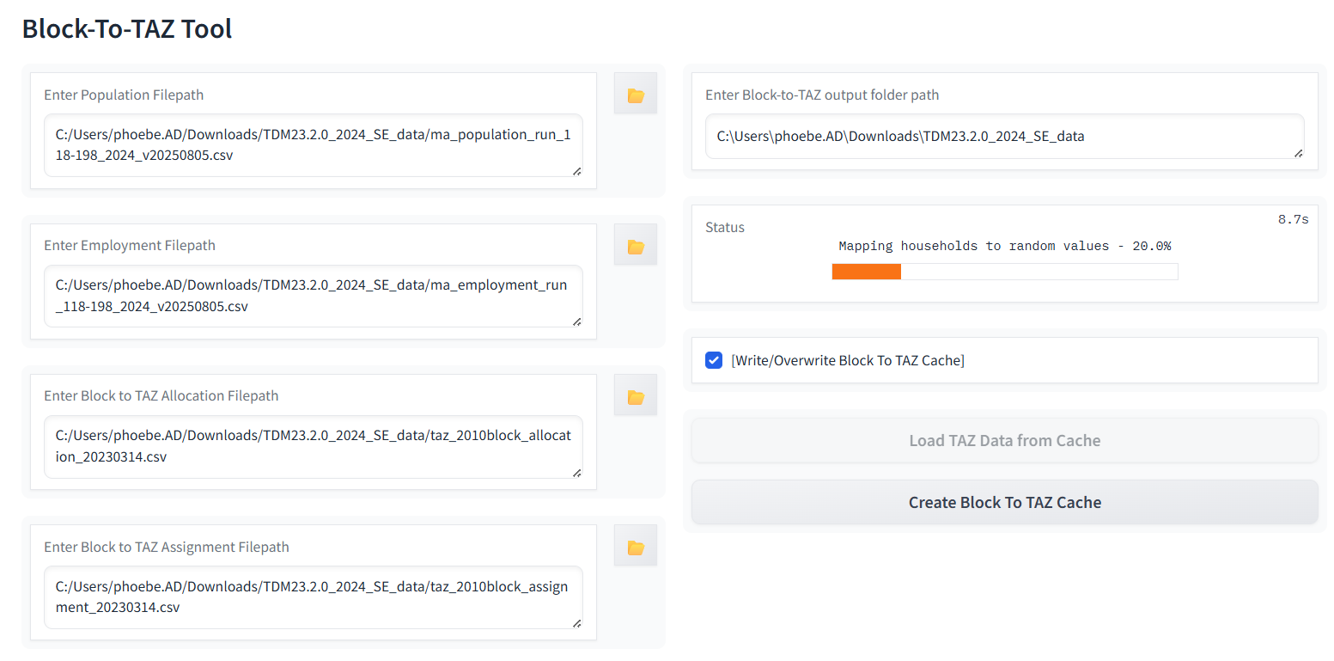

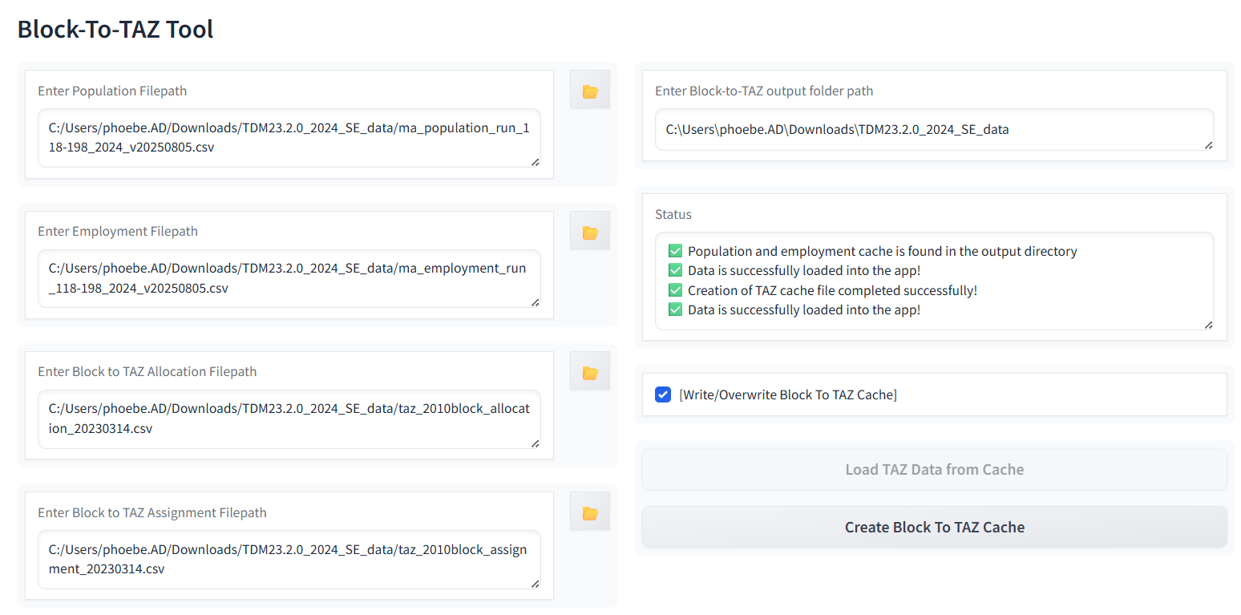

Step 4: Place the files into the STOPS SE Data Preprocessor and Setup Tool JSON Config

J:\Shared drives\TMD_TSA\Projects\STOPS\[Model Input Preprocessors]\SE Data

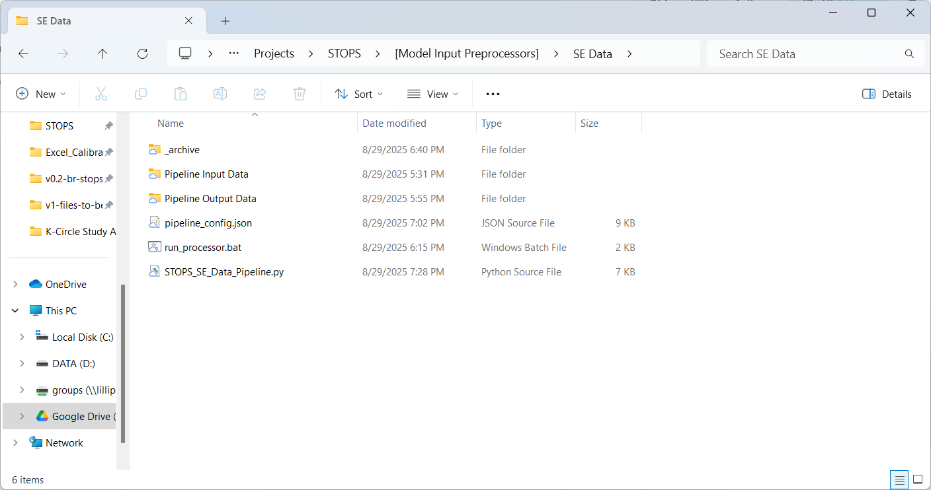

J:\Shared drives\TMD_TSA\Projects\STOPS\[Model Input Preprocessors]\SE Data\Pipeline Input Data\UrbanSim TAZ SE Data\2025AugRun_BlockDataConversion

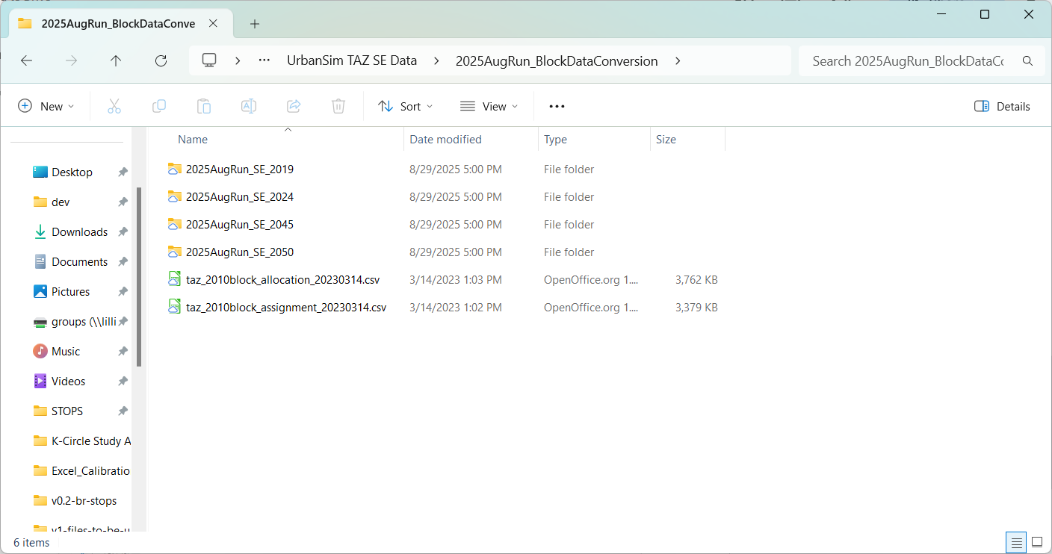

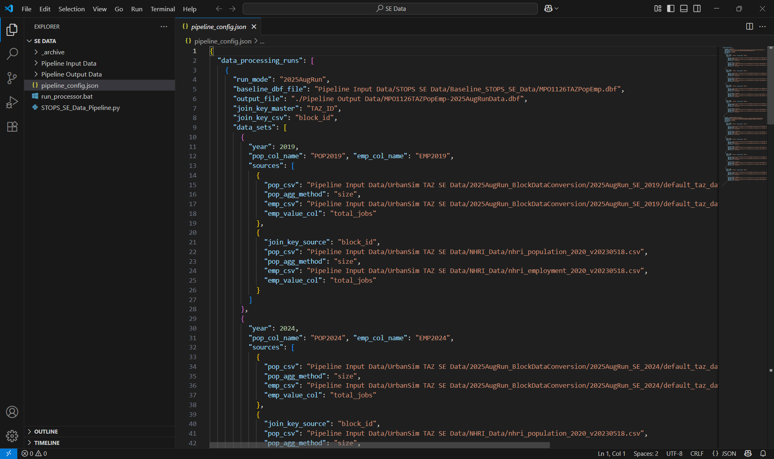

Step 5: Run SE Data Preprocessor with TAZ Data

*\* NOTE: Anaconda/Miniconda installation & TDM23_env_1 is required*

*\* NOTE: DBF Package is also required (to write new DBF File)*

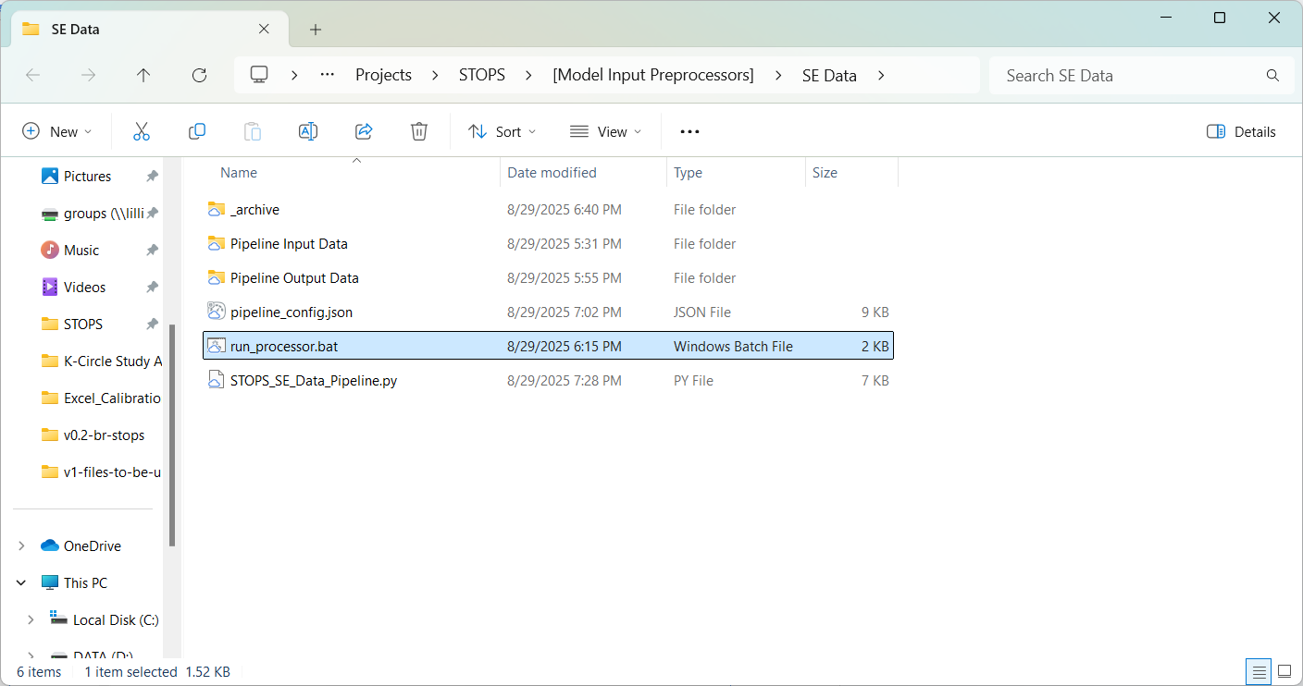

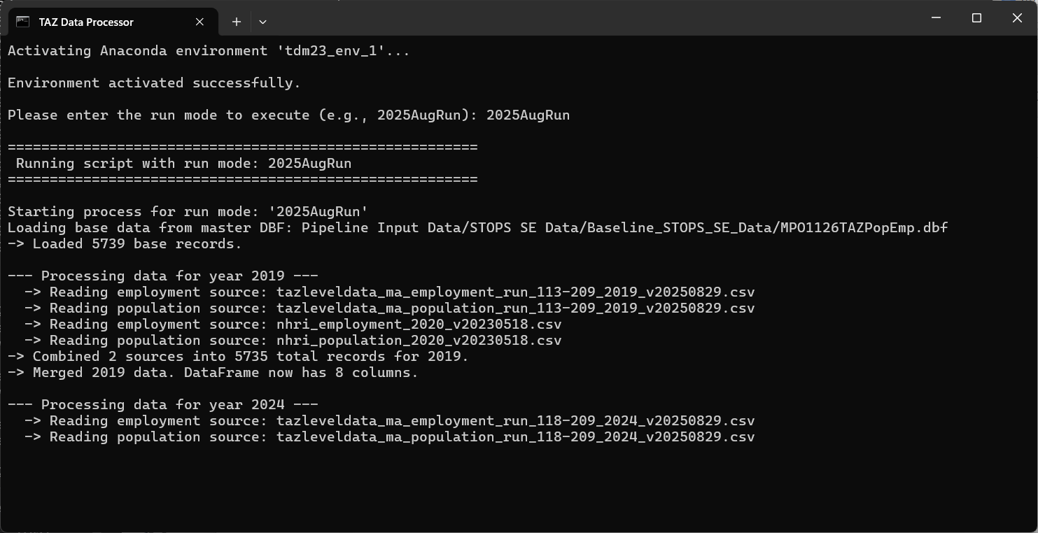

Step 6: Receive Preprocessor Output Data

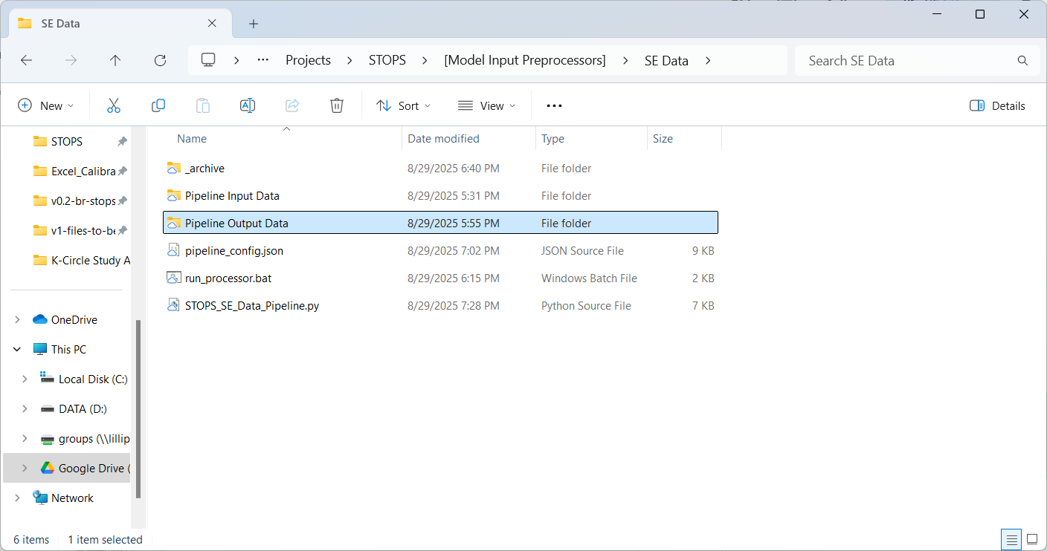

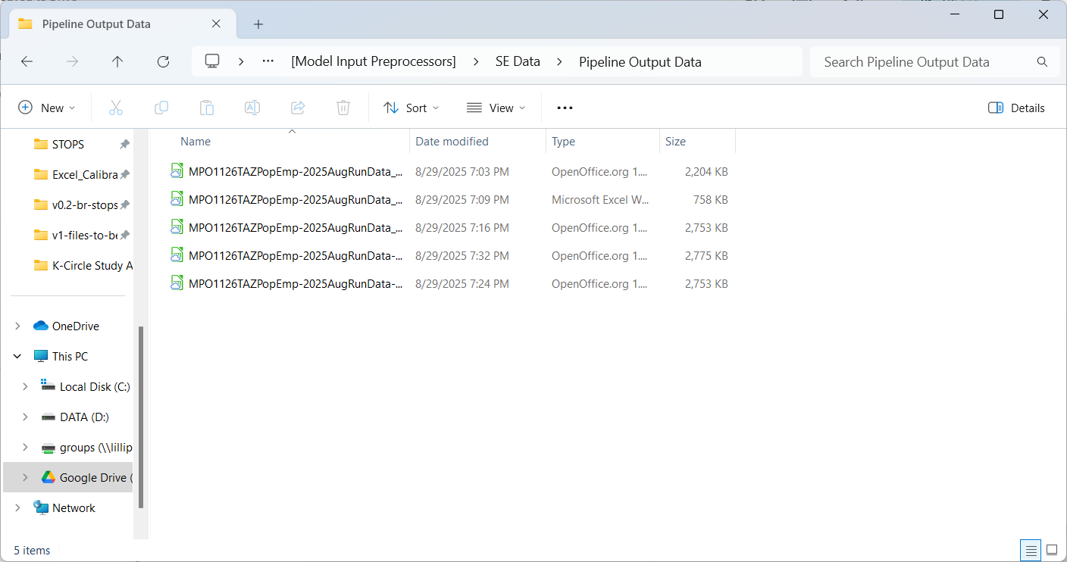

Step 7: Replace POP & EMP in STOPS

Update the MPO1126TAZPopEmp.dbf in the STOPS Input and update configuration to use new SE Data

